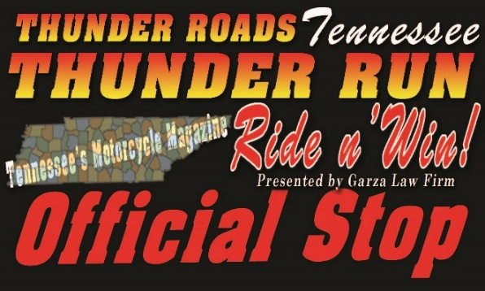
2nd Annual Ride n’ Win Contest
Presented By Thunder Roads® Magazine of Tennessee
And Garza Law Firm
TENNESSEE’S #1 FREE MOTORCYCLE MAGAZINE!

Thunder Roads® Tennessee is proud to present the 2017 Tennessee Ride n’ Win Contest. This is a state-wide, summer-long riding contest. We will list businesses each month for our readers to check-in at as a riding destination and also we will be targeting events across Tennessee. This is a riding contest like no-other and features great prizes every month to participants.
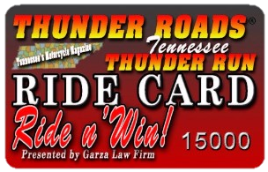
As part of the contest, we will be registering riders for a FREE Thunder Roads Ride Card – with which they can check-in at various stops across the state as part of the contest. We will also be encouraging sponsors to offer additional incentives to riders carrying the cards – all building interest in and awareness of the promotion.

In regards to featured stops, we will be limiting it to a reasonable number each month.
We will feature about 40-60 ride stops across Tennessee. We are NOT simply adding anyone willing to write a check. We will be considering stops recommended by our readers and we will only select those that offer a legitimate interest to riders – making them worth the ride to visit. The Ride n’ Win contest is designed to encourage riders to get out and discover new destinations and frequent their favorite stops more often.
Please contact us as soon as possible if you are interested in participating. We look forward to hearing from you!

Scott & Denise High
Thunder Roads® Magazine of Tennessee Owners / Publishers
Cell 615-389-1149 or 615-389-1016
TennesseeThunderRun@gmail.com

PLEASE NOTE: The 2017 Tennessee Thunder Run Ride n’ Win contest information is being circulated CONFIDENTIALLY for consideration within your organization only. Please do not distribute beyond as it contains materials and information considered proprietary and of a competitive nature.

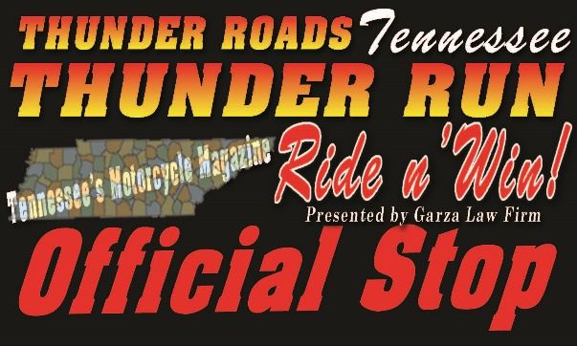

EARLY BIRD SPECIALS

(Must Pay by 4/15/17)
To sign-up to be an Official Ride Stop, please fill out the application as you would like it listed in the magazine (don’t forget to write down the prize you will be giving away each month to one lucky person that checks-in at your business). Winners are selected randomly each month by Thunder Roads® Magazine of Tennessee and notified in the following magazine issue. We keep it simple for you and for the customers!

Registration Stop - $1000 *EARLY BIRD SPECIAL only $625 Total (Must Pay by 4/15/17)

*Special Early Bird Rate $625- if pay by 4/15/17 – Featured Stop May-Sept issues (ONLY $125 a Month)
Location would be featured as a summer-long registration stop and listed in the magazine as well as online for riders to get their Free Ride Card (a limited amount of Registration Stops allowed; based on geographical location). You will be supplied with Ride Cards, Window Decals, Counter Tent Signs, Release Forms and Sign-in sheets. Riders can also check-in weekly with their Ride Card. Must giveaway one monthly prize (value = at least $25).

Summer-Long Stop - $600 *EARLY BIRD SPECIAL only $375 Total (Must Pay by 4/15/17)

*Special Early Bird Rate $375- if pay by 4/15/17 – Featured Stop May-Sept issues (ONLY $75 a Month)
Location will be featured as a summer-long stop and listed in the magazine as well as online. You will be supplied with Window Decals, Counter Tent Signs, and Sign-in sheets. Riders can check-in weekly at these stops all summer-long once they have received their Free Ride Card at a Registration Stop. Must giveaway one monthly prize (value = at least $25).

Event Stop - $325 (plus prize) *EARLY BIRD SPECIAL only $225 Total (Must Pay by 4/15/17)

*Special Early Bird Rate $225- if pay by 4/15/17 – Featured Stop one month only in a May-Sept issue

Event will be listed as an Official Thunder Roads Event Stop in the magazine. Cost also includes a quarter page ad in the magazine to promote the stop (one month) – which can be upgraded to a larger ad size. In most cases, as schedule allows, we will also have a Thunder Roads representative on site for the event as well. For multi-day events, please contact us as this rate is based on a single day of registrations. Prize consideration includes some event specific prizes that will be awarded to riders from your event – can include event tickets, t-shirts, gift card, etc.

